**FOOD ORDERING SYSTEM UML DIAGRAMS**

**NAME: B.NITHESH KUMAR**

**REGNO: 192011035**

**1.USE CASE DIAGRAM**

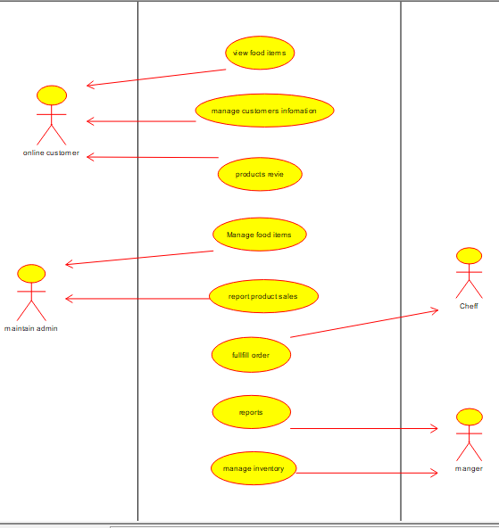

**2.SEQUENCE DIAGRAM**

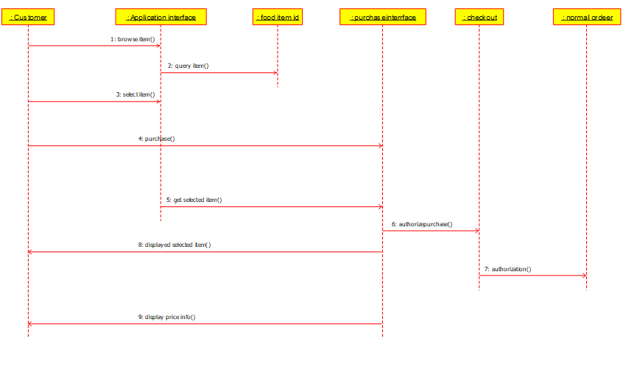

**3.CLASS DIAGRAM**

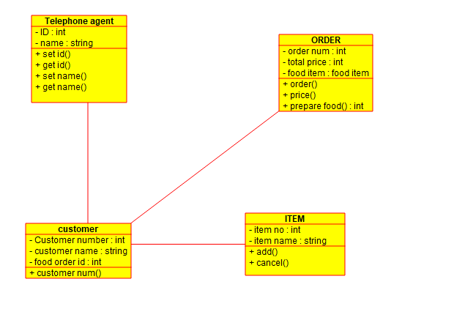

**4.STATE DIAGRAM / ACTIVITY DIAGRAM**

